**DATA FLOW DIAGRAM & TABLE FOR DETECTING E- BANKING PHISHING WEBSITE**

**LEVEL-0-DFD**

Request

Response

Detect

Phishing

Admin

User

Request

Response

**LEVEL-1-DFD**

**ADMIN**

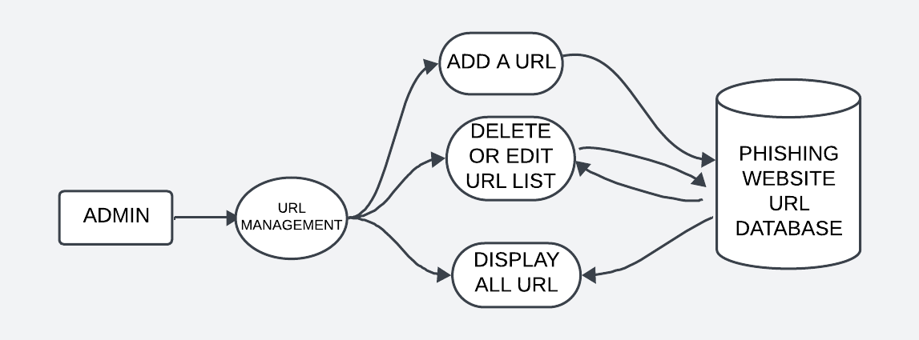

**USER**

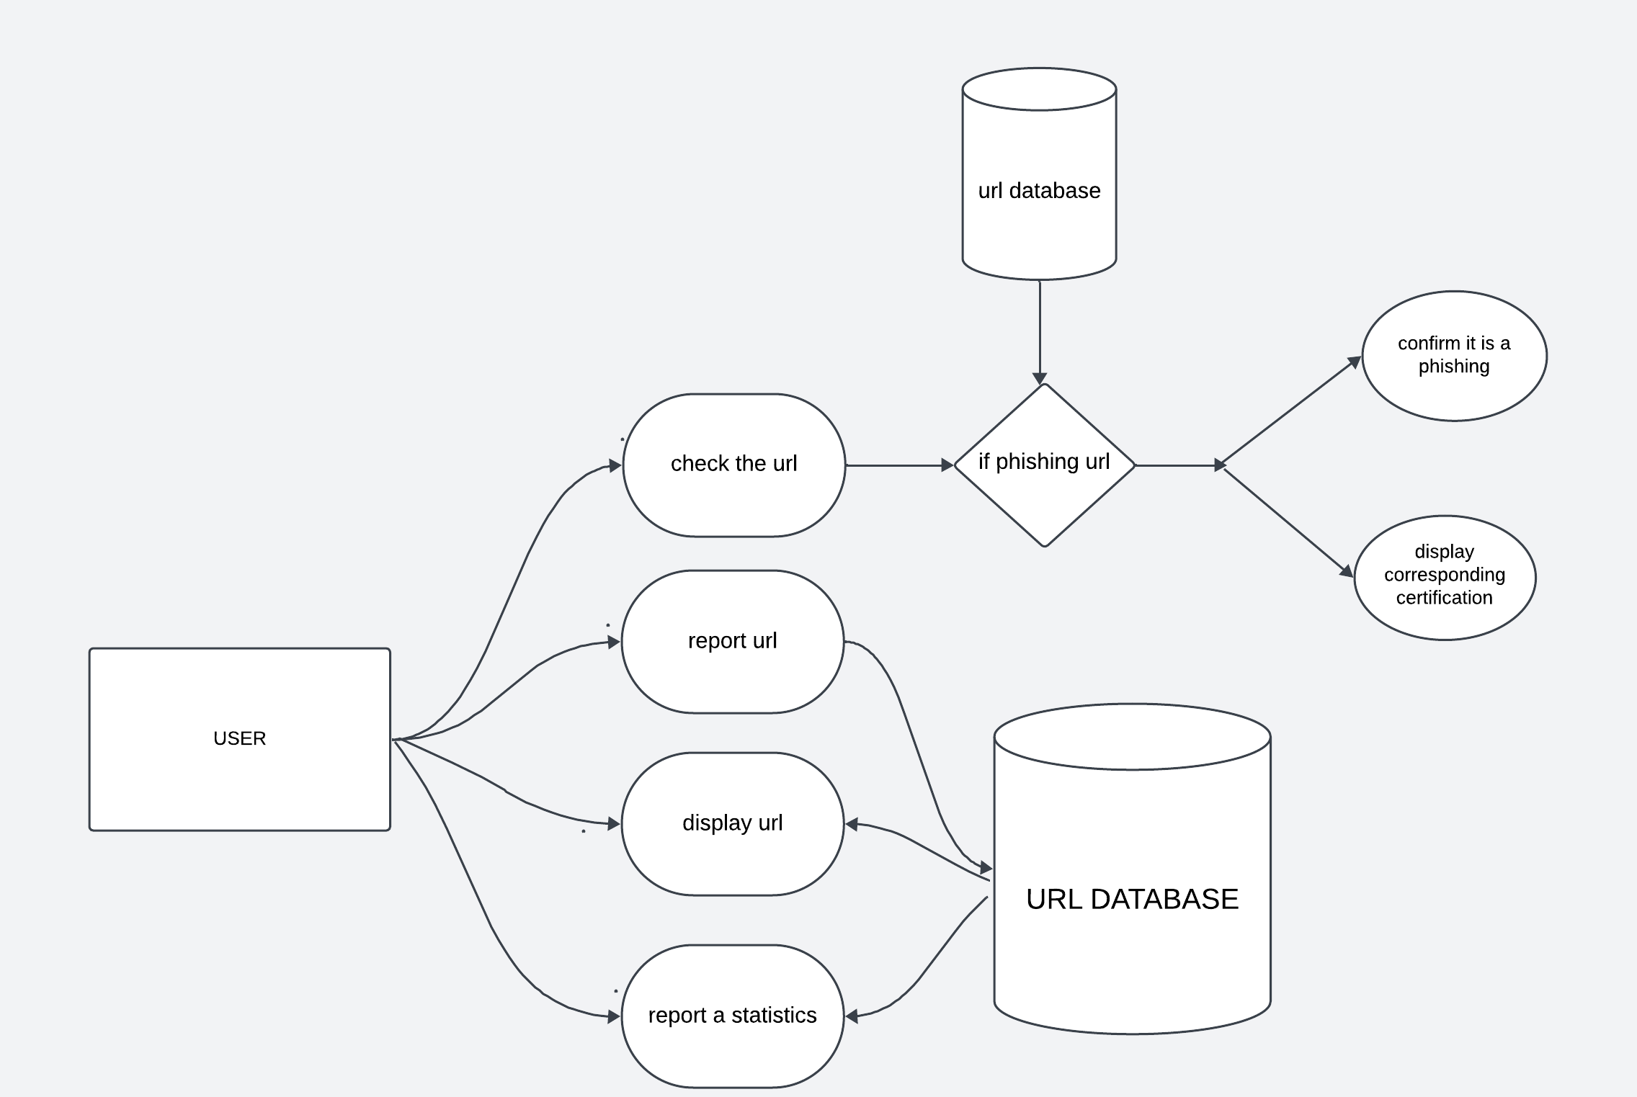

**LEVEL-2-DFD**

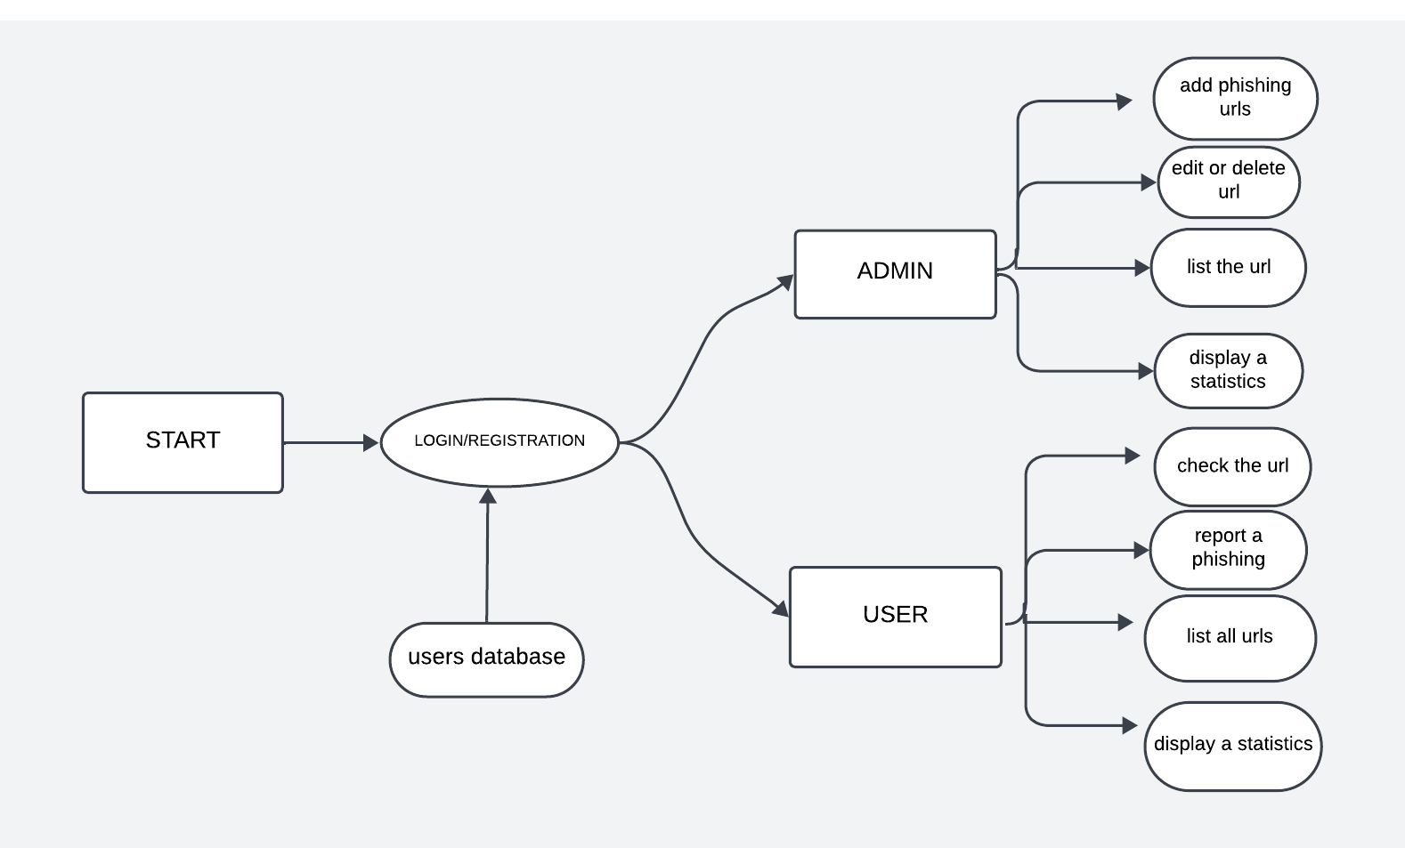

**TABLE 1**

TABLE NAME:user

DESCRIPTION: This is the main table that stores the user details.

Primary key: id

|  |  |  |  |  |
| --- | --- | --- | --- | --- |
| COLUMN_NAME | DATATYPE | SIZE | CONSTRAINTS | DESCRIPTION |
| id | int | 10 | Primary key | id of the  user |
| username | varchar | 50 | Not Null | Name of the  user |
| password | varchar | 255 | Not Null | Password of the user |
| email | varchar | 150 | Not Null | email of the user |
| Created_at | timestamp | 50 | Not Null | Date at which the user signed up |
| role | tinyint | 1 | Not Null | To determine whether the user is admin or not |

**TABLE 2**

TABLE NAME:urlsnew

DESCRIPTION: This table stores the details of the website.

Primary key: id

|  |  |  |  |  |
| --- | --- | --- | --- | --- |
| COLUMN_NAME | DATATYPE | SIZE | CONSTRAINTS | DESCRIPTION |
| id | int | 10 | Primary key | id of the  website |
| url | varchar | 255 | Not Null | url of the  website |
| If_phish | int | 50 | Not Null | To check if the website is phishing or not not. |

**TABLE 3**

TABLE NAME:user_reported_urls

DESCRIPTION:This table stores the urls reported by the user.

Primary key:id

|  |  |  |  |  |
| --- | --- | --- | --- | --- |
| COLUMN_NAME | DATATYPE | SIZE | CONSTRAINTS | DESCRIPTION |
| id | int | 10 | Primary key | id of the user |
| User_name | varchar | 255 | Not Null | name of the user |
| reported_url | varchar | 255 | Not Null | reported url |
| reason | text | 50 | Not Null | the reason to report the corresponding url |
| date_reported | timestamp | 20 | Not Null | date at which the url is reported |

**TABLE 4**

TABLE NAME:url_check_history

DESCRIPTION:This table logs details of every URL check performed.

Primary key:id

|  |  |  |  |  |
| --- | --- | --- | --- | --- |
| COLUMN_NAME | DATATYPE | SIZE | CONSTRAINTS | DESCRIPTION |
| id | int | 10 | Primary key | id of the user |
| url | varchar | 255 | Not Null | checked url |
| Checked_at | datetime | 50 | Not Null | date at which the url is checked |